***PAAREES PERFUMES***

***DAVIDOFF***

***FOR WOMEN***

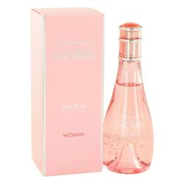

***Cool Water Sea Rose***

***Description:***

Cool Water Sea Rose by Davidoff Perfume. If you're looking for an airy, fruity scent that is perfect for any occasion, splash on a little Cool Water Sea Rose. Introduced by Davidoff in 2013, this new women's fragrance is ideal for women who enjoy refreshing and youthful scents. Pear overtones remind you of a visit to the summer market, while faint notes of pink peony give the fragrance a slight floral tone. Cool Water Sea Rose is a versatile fragrance that you can wear to the office or to casual dinner parties with friends.